New IARU R1 Distance Record at the 241 GHz Band

On March 6th, 2021 during the March Contest, Michael DB6NT and Matthias DK5NJ decided to start a new record attempt in the 241 GHz band due to the good weather conditions for the millimeter waves.

First, DB6NT drove together with Matthias DG2NES to Schöneck in JO60DJ. Matthias DK5NJ stayed at the Schwedenwache (DK0NA) in JO50TI. There he devoted himself to the contest in the 70 cm band while waiting. The weather report already indicated that the connection to Schöneck could work: With a relative humidity of approx. 36 % and + 3 ° C temperature - with bright sunshine and clear sight - the first record was set to great cheers on both sides this day with a bridged distance of approx. 52 km.

But that's not all. Due to the good reports and the relatively rare weather conditions, DB6NT and DG2NES continued on their way to Aschberg. The Aschberg (Czech Kamenáč) is a 936 m high mountain in the Saxon-Czech border area near Klingenthal in Vogtland, the summit of which is in the Czech Republic. The summit is at an altitude of 917 m.

In the twilight, the already achieved daily record could then be surpassed from there. To everyone's delight, the CW QSO on both sides with 599 took place at 17:10 UTC.

Here are the exact key data of the connection:

17:10 UTC: DK5NJ in JO50TI29JN 690m ASL DB6NT in JO60GJ03MN 896m ASL

Bridged distance: 63,987 km

The reports in CW were 599 on both sides

The relative humidity was now 45% and the temperature was -1 ° C.

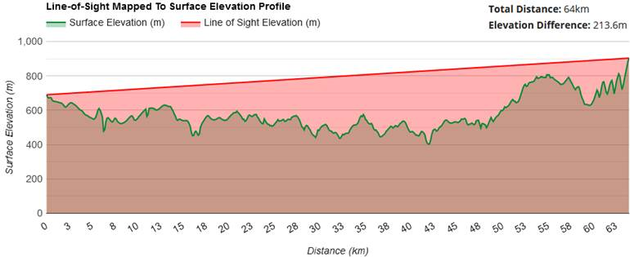

Both receivers worked with a subharmonic mixer with 120 GHz LO frequency. The transmission power was 20 mW. 40 cm parabolic mirrors with a gain of 57 dB at a beam angle of less than 0.25 ° were used as antennas.

There was a line of sight and so the antennas could also be aligned using Rifle scopes. The signal strengths were about 30 dB above the noise so that 100 km would have been possible that day.

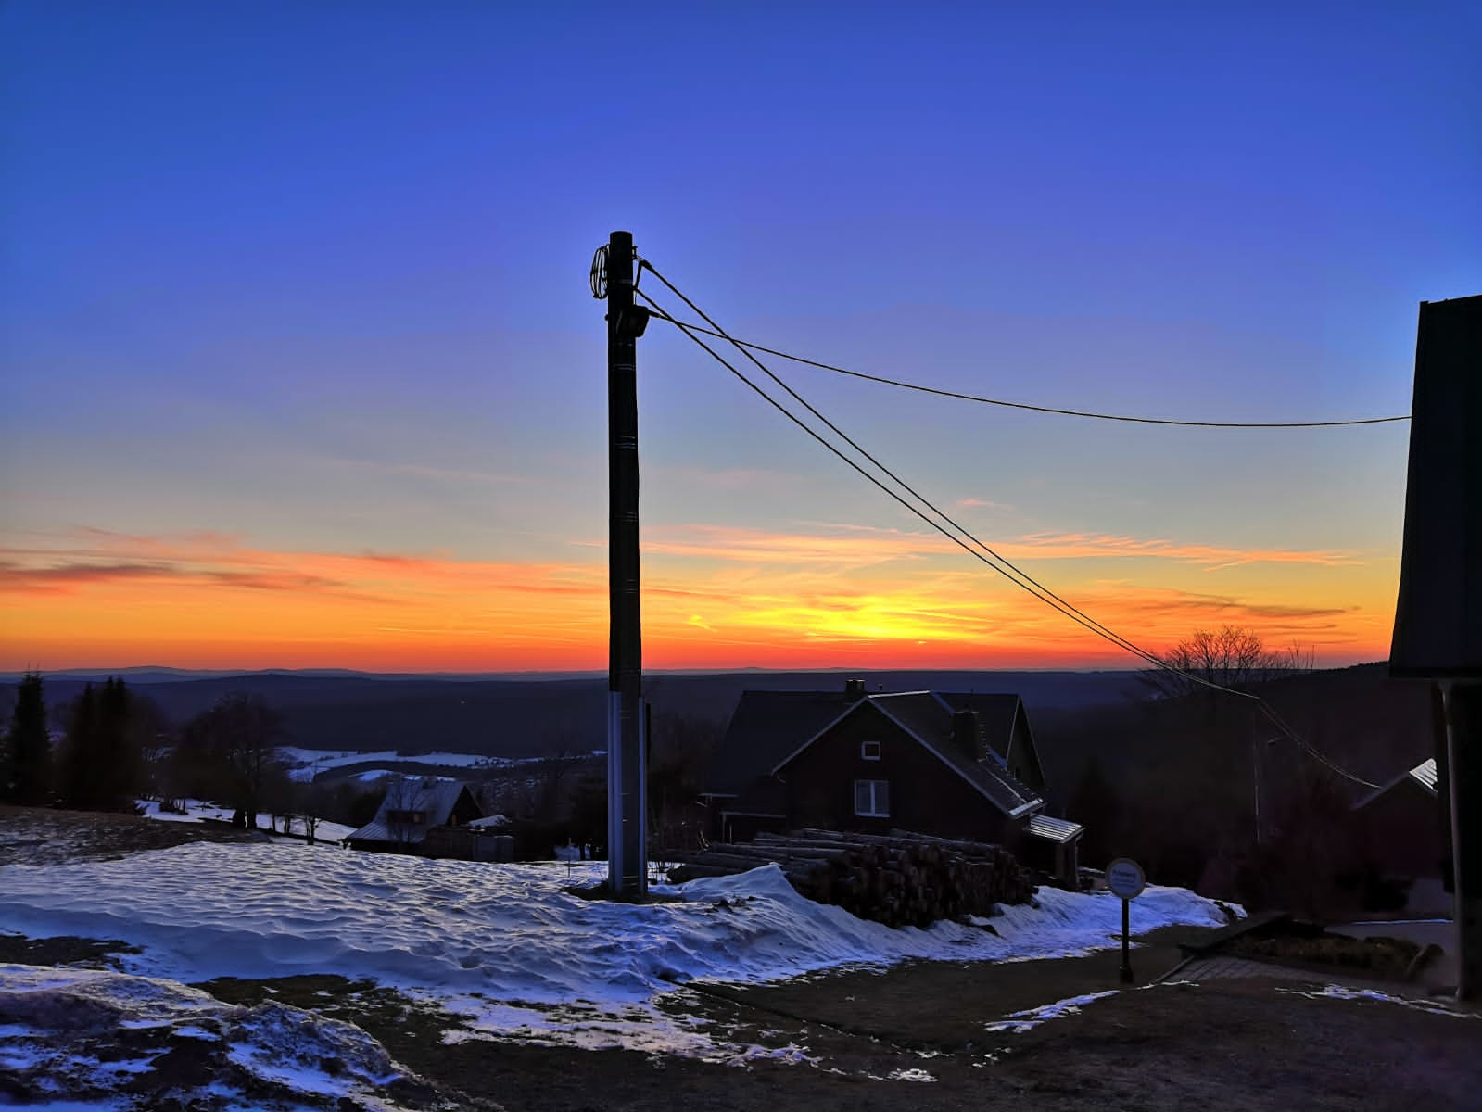

View from the Aschberg JO60GJ03MN to the direction of Schwedenwache JO50TI29JN

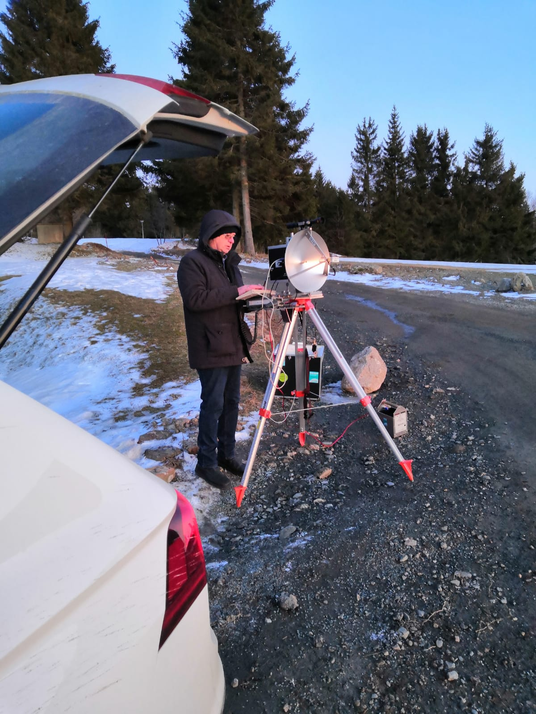

Michael DB6NT in QSO with DK5NJ

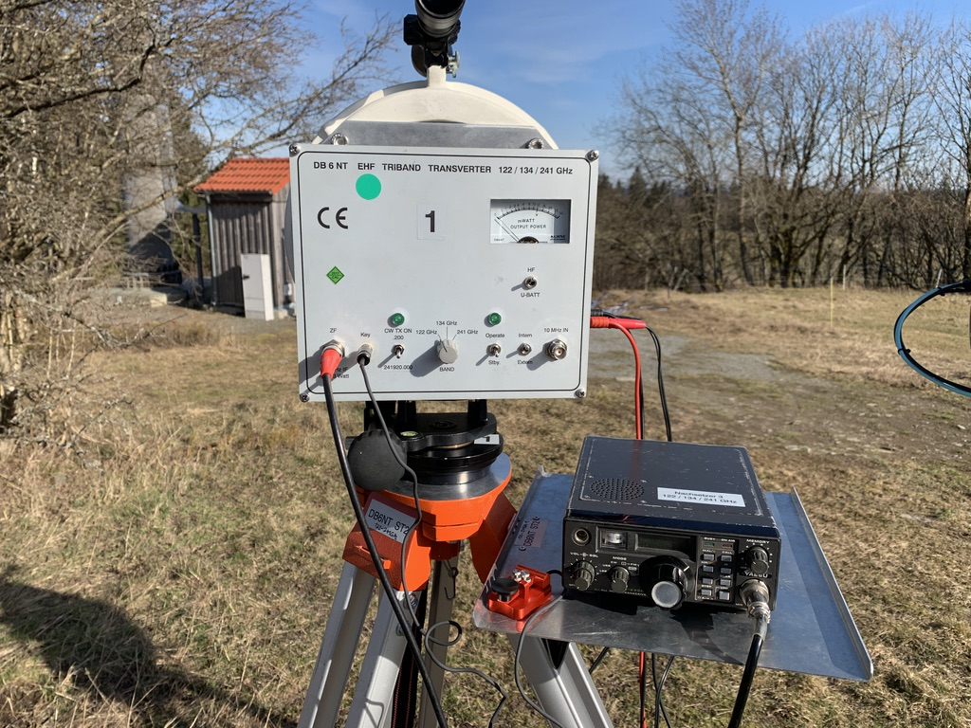

Setup of DK5NJ at the Schwedenwache JO50TI (DK0NA)
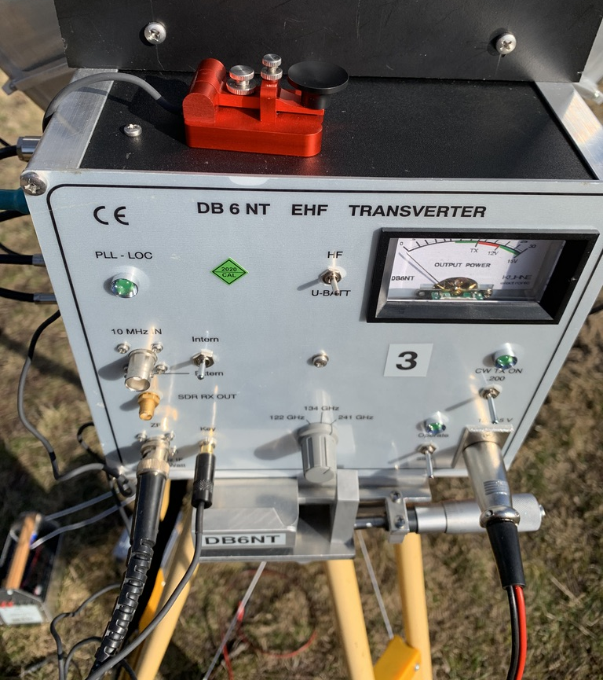

Working condx with the new 241 GHz setup at DK5NJ (the Transverters for 122/136 GHz are also intended to be in this case but this project isn’t finished yet)

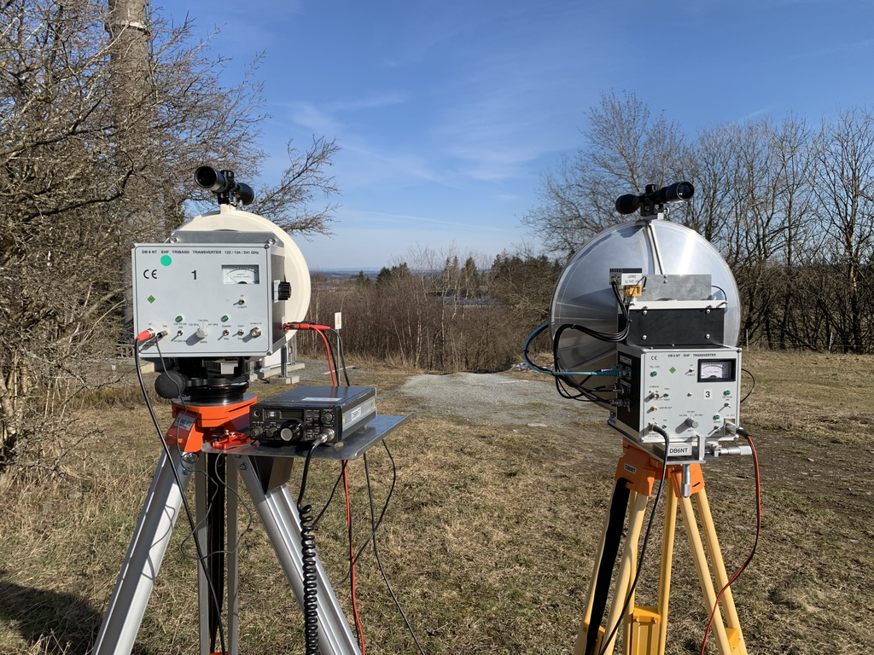

On the left is the triband-rig 122/134/241 GHz at DK5NJ (Schwedenwache JO50TI) and on the right side the new tri-band-rig with only 241 GHz inside – up to now…
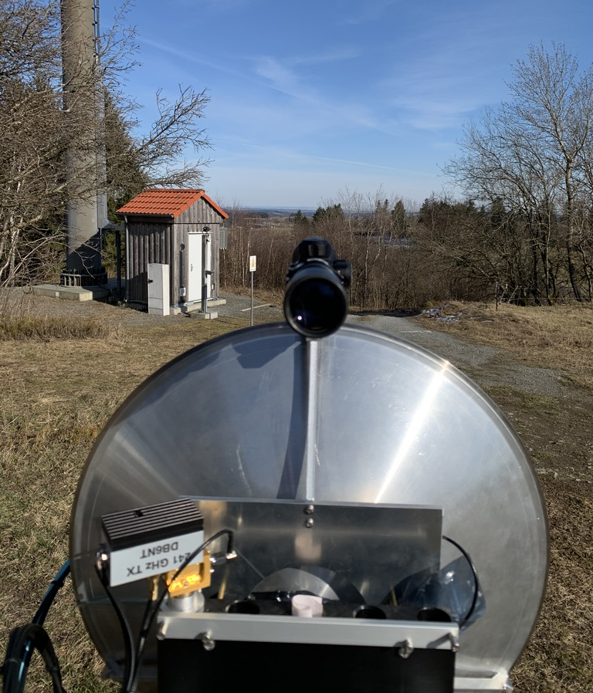

View from the Schwedenwache in the direction of Schöneck/Aschberg

Many thanks to Matthias DG2NES and Alex DH1NAX who really helped us. Further thanks go to our wives and families who support us again and again!

Despite the relatively rare weather conditions, we hope to be able to report on a sequel again in the future.

Here you can find a short video of the QSOs: https://youtu.be/eVJC4lfpyuo

73 de DB6NT + DK5NJ
Michael & Matthias

